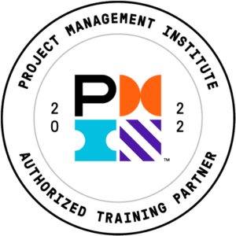

FY20 Build

**Project Management Professional Certification (PMP)**® **(2021 PMI ATP Aligned)**

**Instructors**

**Name:** Orlando Sequera

**Bio:** Orlando is a certified Project Management Professional (PMP)® and PMI Agile Certified Practitioner (PMI-ACP) ® with over 15 years in IT. He has worked as a Project Manager in different industries including Travel and Tourism, Healthcare, and Aerospace. In Aerospace, he manages software development projects for the Artemis program with NASA to land the first woman and the next man on the Moon. Orlando received his bachelor’s degree in Systems Engineering from Universidad Santa Maria – Venezuela and his master’s degree in Project Management from Boston University.

**Image:**

**Instructors Cont’d**

**Name:** Priscilla Bakx-Kabai

**Bio:** Priscilla is passionate about people and projects. She helps project professionals to become great by providing training and coaching in hard and soft skills that are founded on a People First Mindset. Priscilla is an Authorized Training Partner Instructor (ATP-I) of the Project Management Institute, the PMO Officer at Ricoh Europe Supply Chain BV and a certified Mindset Coach and Change Facilitator by The Arbinger Institute. Her professional vision is captured in the name of her company, Go ROHO, which stands for Go Reach One Help One. Three words that best describe Priscilla’s way of working are Engagement, Communication, and Teamwork.

**Image:**



**Instructors Cont’d**

**Name:** Susan Daniels

**Bio:** Susan Daniels, MBA, PMP, DASSM, ATP-I served on the Project Management Institute’s (PMI) global task force to define certification requirements. She also contributed to the framework of the PMP exam and PMBOK 7th edition.

In her career Susan has served as an Executive Director for a multimillion-dollar social services agency and a Sr. Strategy Integrator for a $12 billion enterprise in the healthcare field. Most recently she has been engaged with the University of North Florida and Brenau University to lead their Project Management programs at the undergrad and graduate levels. When Susan is not teaching certification courses via global webinars, she is consulting with fortune 500 companies on how to deliver value sooner.

**Image:**

**Course Syllabus**

**Project Management Professional Certification (PMP)**® **(2021 PMI ATP Aligned)**

We are glad you have joined us for this course! Here is some information that will help you to navigate your learning platform and locate course content.

**Joining the Session**

Before the first live session please confirm that you can access Zoom:

1. Visit <https://support.zoom.us> and click on **Getting Started**.

2. Attn Percipio Users - The **Join Now** option is available where you registered for the session in Percipio 15 minutes prior to the start of class.

3. Attn Skillport Users - The **Join** link is available 45 minutes from the Live Session # Details prior to the start of each class. Please click the **Join** link and then **Download and Run Zoom**.

4. Attn All Other Learning Platform Users – Please check with your training provider for information about joining the session.

**Course Description**

This course provides Project Managers with the knowledge and skills needed to attain the Project Management Professional (PMP®) certification. This course meets the 35-hour classroom requirement for the PMP® Exam. Classes are taught by badged Authorized Training Provider (ATP) instructors who have their PMP® credential, with real life experience in both traditional and agile Project Management approaches. In addition to the 35 classroom hours, students will receive access to a practice exam simulator and mentors who are available to provide guidance and answer questions about the PMP® curriculum.

**Target Audience**

This course is designed for the individuals who have on-the-job project management experience regardless of whether their formal job role is project manager, who are not certified project management professionals, and who might or might not have had formal project management training. The course enables candidates to develop professionally, increase their project management skills, apply a formalized and standards-based approach to project management, and seek career advancement by moving into a formal project manager job role, as well as to apply for the Project Management Institute’s Project Management Professional (PMP)® certification.

**Skills/Objectives**

In this course, you will learn how to build and manage a team, and to plan, execute, and complete a project that is aligned to the business environment. You will learn the tools and techniques to:  
• Create a high-performing team  
• Plan and manage the project  
• Execute and assess the project work  
• Keep the team on track  
• Keep the business environment in mind

**PMP® Exam Prerequisites**

Before you apply, please review the following set of PMP® Certification requirements:

A four-year degree

36 months leading projects

35 hours of project management education/training or CAPM® Certification

— OR —

A high school diploma or an associate degree (or global equivalent)

60 months leading projects

35 hours of project management education/training or CAPM® Certification

— OR —

Bachelor's or post-graduate degree from a GAC accredited program *(bachelor’s degree or master's or global equivalent)

Minimum two years/24 months unique non-overlapping professional project management experience

35 hours of project management education/training or CAPM® Certification

Note: If you are a graduate of a GAC accredited degree program, you will receive a 12-month credit towards the work experience requirement. Also, you can use the GAC course work to fulfill the 35-education contact hour requirement. Learn more about the PMI Global Accreditation Center for Project Management Education Programs (GAC).

If you have any questions about your situation regarding the PMP Exam Prerequisites, please contact [PMI Customer Care](https://www.pmi.org/about/contact) directly.

**Authorized Training Partner (ATP) Training**

An Authorized Training Partner (ATP) is an organization that PMI has approved to offer PMP certification exam prep using the official PMI curriculum that is aligned with the exam.

**Attendance Requirements for Course Completion**

It will take approximately 35 hours to complete the Bootcamp sessions.

Special Note for PMP Candidates: The Project Management Institute requires live, real-time attendance in our live instructor-led classes in order for your attendance to count*. For more information about attendance, see the PMP 5 Day and 8 Day Attendance video in your Bootcamp resources.*

**Required PMP Learner Kit**

Please note that PMI requires all PMP candidates who take ATP training to have a **Learner Kit** prior to taking the PMP Certification Exam. Learner Kit vouchers must be **purchased through Skillsoft** and **redeemed through PMI**. Contact your corporate training staff for more information or watch the **PMP Learner Kit Information Video** [here](https://github.com/Skillsoft-Content/PMP5Day/tree/main/5-Day%20Attendance%20and%20Certificates%20of%20Completion%20Info) in GitHub. The video explains who does/does not need to purchase the kit, how to purchase the kit from Skillsoft and register the kit with PMI, as well as the contents and resources contained in the kit.

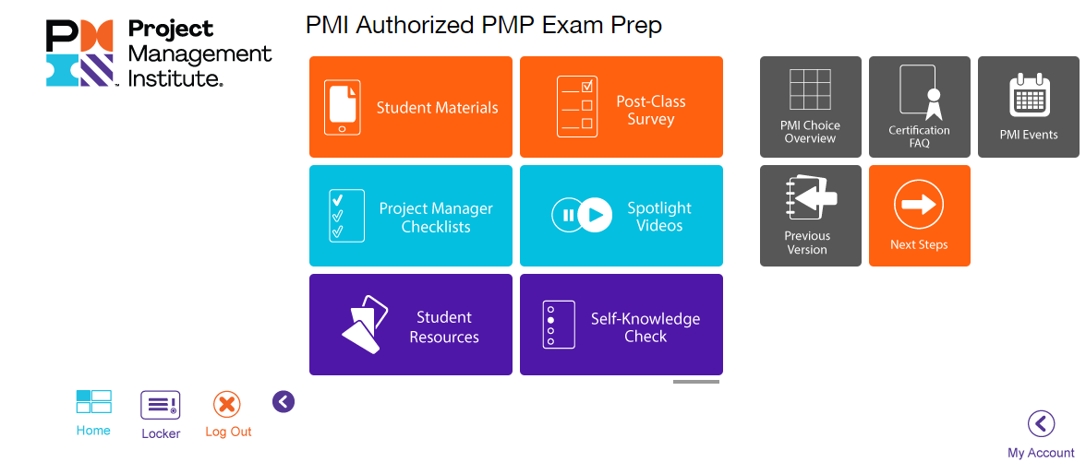

**Bootcamp Syllabus**

**Session 1**

* Introduction to Project Management and the PMP Exam
* Lesson 1: Business Environment
  + Topic A: Foundation
  + Topic B: Strategic Alignment
  + Topic C: Project Benefits and Value
  + Topic D: Organizational Culture and Change Management
  + Topic E: Project Governance
  + Topic F: Project Compliance
* Lesson 2: Start the Project
  + Topic A: Identify and Engage Stakeholders

**Session 2**

* Lesson 2: Start the Project (cont.)
  + Topic A: Identify and Engage Stakeholders
  + Topic B: Form the Team
  + Topic C: Build Shared Understanding
  + Topic D: Project Approach
* Lesson 3: Plan the Project
  + Topic A: Planning Projects
  + Topic B: Scope

**Session 3**

* Lesson 3: Plan the Project (cont.)
  + Topic B: Scope
  + Topic C: Schedule
  + Topic D: Resources
  + Topic E: Budget

**Session 4**

* Lesson 3: Plan the Project (cont.)
  + Topic F: Risks
  + Topic G: Quality
  + Topic H: Integrate Plans
* Lesson 4: Lead the Project Team
  + Topic A: Craft Your Leadership Skills​
  + Topic B: Create a Collaborative Project Team Environment
  + Topic C: Empower the Team
  + Topic D: Support Team Member Performance​
  + Topic E: Communicate and Collaborate with Stakeholders
  + Topic F: Training, Coaching, and Mentoring

**Session 5**

* Lesson 4: Lead the Project Team (cont.)
  + Topic G: Manage Conflict
* Lesson 5: Support Project Team Performance
  + Topic A: Implement Ongoing Improvements
  + Topic B: Support Performance
  + Topic C: Evaluate Project Progress
  + Topic D: Manage Project Issues and Impediments
  + Topic E: Manage Project Changes
* Lesson 6: Close the Project/Phase
  + ​Topic A: Project Phase/Closure
  + Topic B: Benefits Realization
  + Topic C: Knowledge Transfer

**Recommended Hours of Study**

It is recommended that you spend approximately 80-100 hours toward your PMP exam studies. This includes the hours of training, practice exams, and review of the PMBOK Guide and PowerPoint slide content. It is also recommended that you memorize all formulas and familiarize yourself with all the vocabulary in the PMBOK guide glossary.

**Tracking Attendance and PDU Certificate**

Check the Resources option in your Percipio channel **OR** GitHub <https://github.com/Skillsoft-Content/PMP5Day> for the following file that explains how to manually track your attendance and access your PDU certificate.

PMP Bootcamp 5-Day and 8-Day Attendance Tracker and Certificate Request Process.docx

**Technical Support**

We offer 24/7 support if you need assistance with your Percipio learning platform. To access support, click the arrow to the right of your profile and select “Help”.

**Percipio**

**Skillport**

**Course Contact**

Email the mentoring team at [mentoring@skillsoft.com](mailto:mentoring@skillsoft.com).

**Applying to take the PMP Exam?**

You can start the application process from the following web page and work through the steps. If you are not yet certified, you will report your 35 hours *within* your PMP application.

<https://www.pmi.org/certifications/project-management-pmp>

**Already PMP Certified?**

We do not recommend students submit this Bootcamp for PDUs as we have had at least one student that had this course rejected.

You can see a list of the Skillsoft courses that have been Pre-approved for PDUs from the Excel file you can access from the Skillsoft PMI PDU courses option at this web page.

<https://www.skillsoft.com/accreditation-programs>

Note: After you open the file, select the Active Library tab for English courses. You will be able to see the columns related to each of the three skills to see how the PDUs are categorized for a given course.

Keep in mind that any Skillsoft training that you completed before you sat the exam cannot be used towards the 60 PDUs.